**Vel Tech Rangarajan Dr. Sagunthala R&D Institute of Science and Technology**

 **(Deemed to be University Estd. u/s 3 of UGC Act, 1956)**

**School of Computing**

**B.Tech. – Computer Science and Engineering**

**VTR UGE2021- (CBCS)**

Academic Year: 2025–2026

SUMMER SEMESTER - SS2526

Course Code : 10211CS207

Course Name : Database Management Systems

Slot No : S1L4

DBMS TASK - 9 REPORT

Title: **CRUD operations in Graph databases**

Submitted by:

|  |  |  |
| --- | --- | --- |
| **VTUNO** | **REGISTER NUMBER** | **STUDENT NAME** |
| VTU29796 | 24UECS0712 | M.Gowtham Naga Lakshman |

**TASK 9**

**CRUD operations in Graph databases**

**AIM:**

To perform CRUD operations like creating, inserting, querying, finding, deleting operations on graph spaces.

**The steps to get started with Neo4j's Aura Graph Database:**

**Step1:** Copy and paste the following link into your web browser: https://neo4j.com/cloud/platform/aura-graph-database/?ref=docs-get-started-dropdown

**Step2:** Click on "Start Free."

**Step3:** Choose the option to "Continue with Google."

**Step4:** Click the "Open" button.

**Step5:** After clicking "Open," a text file will be automatically downloaded. This file contains your user ID and password details.

**Step6:** Copy the password from the downloaded text file and paste it where required.

**Step7:** Close the "Get started with Neo4j with beginner guides" if it's open.

**Sep8:** You're now ready to begin practicing with the Graph Database.

## **Create Node with Properties**

Properties are the key-value pairs using which a node stores data. Create a node with properties using the CREATE clause and need to specify these properties separated by commas within the flower braces “{ }”.

**Syntax**

CREATE (node:label{ key1: value, key2: value, . . . . . . . . . }) return node

To verify the creation of the node, type and execute the following query in the dollar prompt.

**Syntax:**

MATCH (n) RETURN n

**Creating Relationships**

To create a relationship using the CREATE clause and specify relationship within the square braces “[ ]” depending on the direction of the relationship it is placed between hyphen “ - ” and arrow “ → ” as shown in the following syntax.

**Syntax:**

CREATE (node1)-[:RelationshipType]->(node2)

**Syntax:**

MATCH (a:LabeofNode1), (b:LabeofNode2)

WHERE a.name = "nameofnode1" AND b.name = " nameofnode2"

CREATE (a)-[: Relation]->(b) RETURN a,b

**Deleting a Particular Node**

To delete a particular node and need to specify the details of the node in the place of “n” in the above query.

**Syntax:**

MATCH (node:label {properties . . . . . . . . . . }) DELETE node

Create a graph database for student course registration, create student and dept node and insert values of properties.

**Create a CrickerBoard Node:**

create(cb:CricketBoard{BoardID:'BID01',Name:'Chennai Cricket Board', Address:'Chennai', Phone:9988776699}) returncb

**Create Team Nodes:**

create(t1:Team{teamID:'CCB01',BoardID:'BID01',name:'ABS EXPRESS', Coach:'G.D.RAMESH', Captain:'SAMPATH KUMAR'}) return t1

create(t2:Team{teamID:'CCB02',BoardID:'BID01',name:'AVG EXPRESS',Coach: 'T.KARTHIKH', Captain:'Y.JOHN'}) return t2

**Create Player Nodes:**

create(p1:Player{PlayerID:'1',TeamID:'CCB01',Name:'Raj',Age:23,DateofBirth:'29-JUN-1996', PlayingRole:'Bowler',email:'rajn@gmail.com'}) return p1

create(p2:Player{PlayerID:'33',TeamID:'CCB01',Name:'Anand',Age:23,DateofBirth:'02-JAN-1999', PlayingRole:'Batsman',email:'balajid@gmail.comm'}) return p2

create(p3:Player{PlayerID:'65',TeamID:'CCB02',Name:'Suresh',Age:27,DateofBirth:'02-JUN-1996', PlayingRole:'Batsman',email:'sureshd@gmail.comm'}) return p3

create(p4:Player{PlayerID:'75',TeamID:'CCB02',Name:'Rohit',Age:33,DateofBirth:'02-JUN-1991', PlayingRole:'Batsman',email:'srohit@gmail.comm'}) return p4

**Creating Relationship among CricketBoard and Teams:**

match(cb:CricketBoard{BoardID:'BID01'}),(t1:Team{teamID:'CCB01'}) create(cb)-[r:has]->(t1) return cb,r,t1

match(cb:CricketBoard{BoardID:'BID01'}),(t2:Team{teamID:'CCB02'}) create(cb)-[r:has]->(t2) return cb,r,t2

**Creating Relationship among Players and Teams:**

match(p1:Player{PlayerID:'1'}),(t1:Team{teamID:'CCB01'}) create(p1)-[r1:playfor]->(t1) return p1,r1,t1

match(p2:Player{PlayerID:'33'}),(t1:Team{teamID:'CCB01'}) create(p2)-[r2:playfor]->(t1) return p2,r2,t1

match(p3:Player{PlayerID:'65'}),(t2:Team{teamID:'CCB02'}) create(p3)-[r3:playfor]->(t2) return p3,r3,t2

match(p4:Player{PlayerID:'75'}),(t2:Team{teamID:'CCB02'}) create(p3)-[r4:playfor]->(t2) return p4,r4,t2

**Display All nodes:** match(n) return n

**Output:**

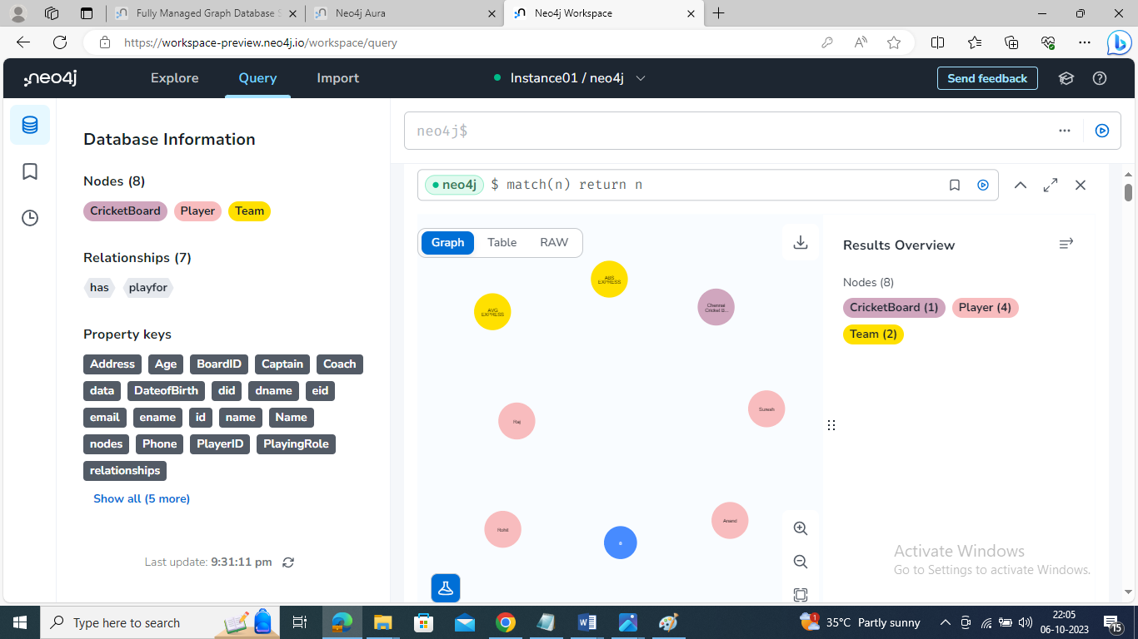

**OUTPUT:**

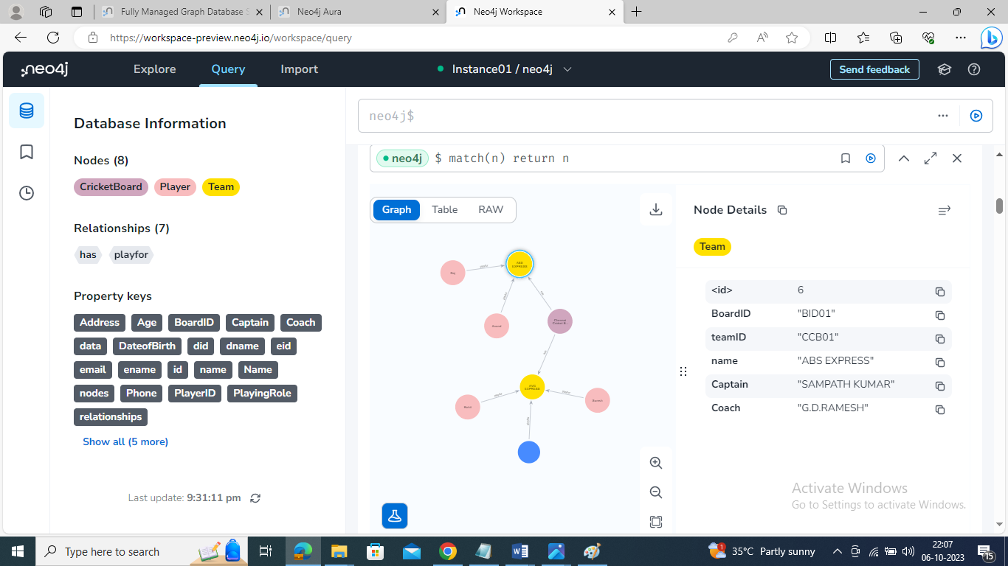

**Retrieve particular player details:**

match(p:Player{PlayerID:'33'}) return p

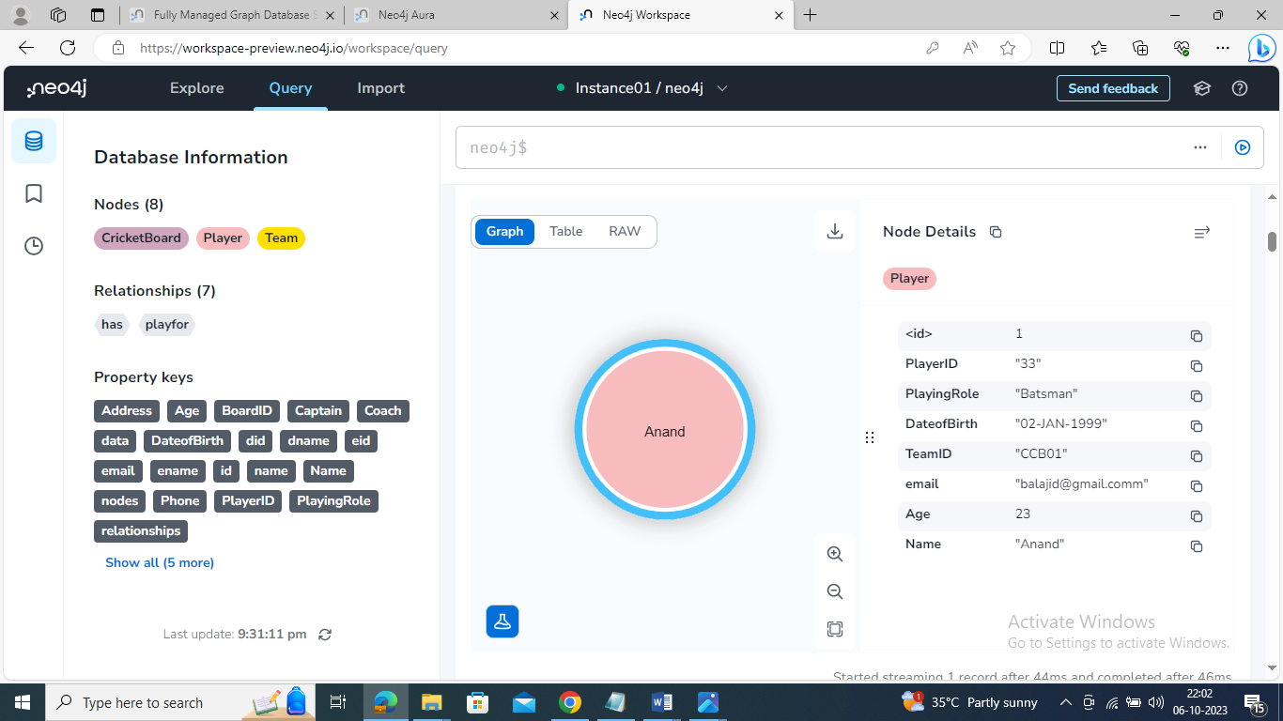

**Update particular player details:**

match(p:Player{PlayerID:'1'}) set p.age=27 return p

**Output:**

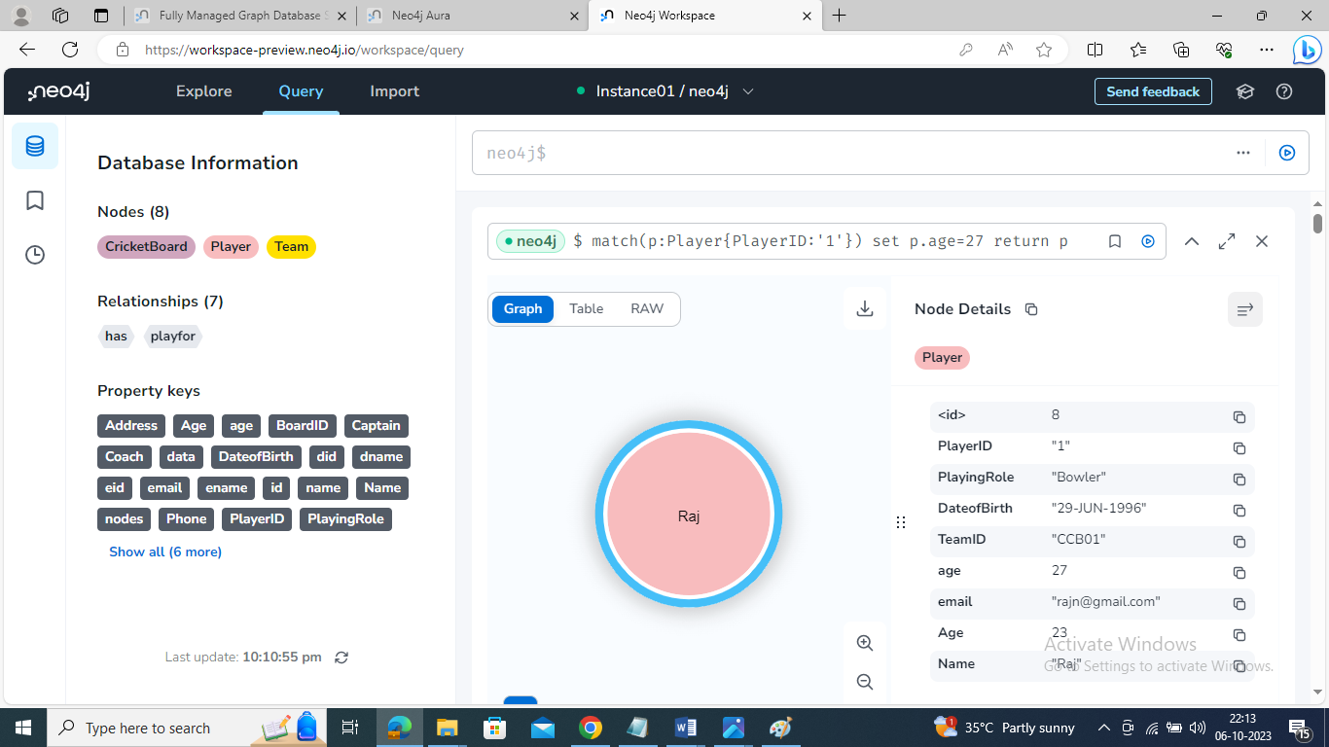

**Delete particular player from the team:**

match(p:Player{PlayerID:'33'}) delete p

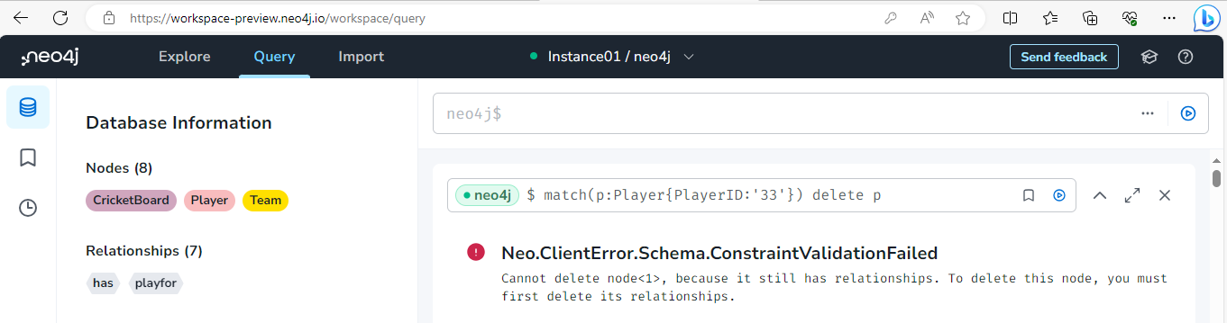

**Result:**

Thus the CRUD operations like creating, inserting, querying, finding, deleting operations on graph spaces were executed successfully.